Chapter 8: Special Senses Name_____________________________
Label the following Diagrams. Place the correct letter in the space provided.
A. Inferior rectus muscle B. Lateral rectus muscle C. Trochlea D. Medial rectus muscle
E. Superior oblique muscle F. Annular ring G. Optic nerve H. Superior oblique tendon
I. Superior rectus muscle J. Inferior oblique muscle K. Conjunctiva

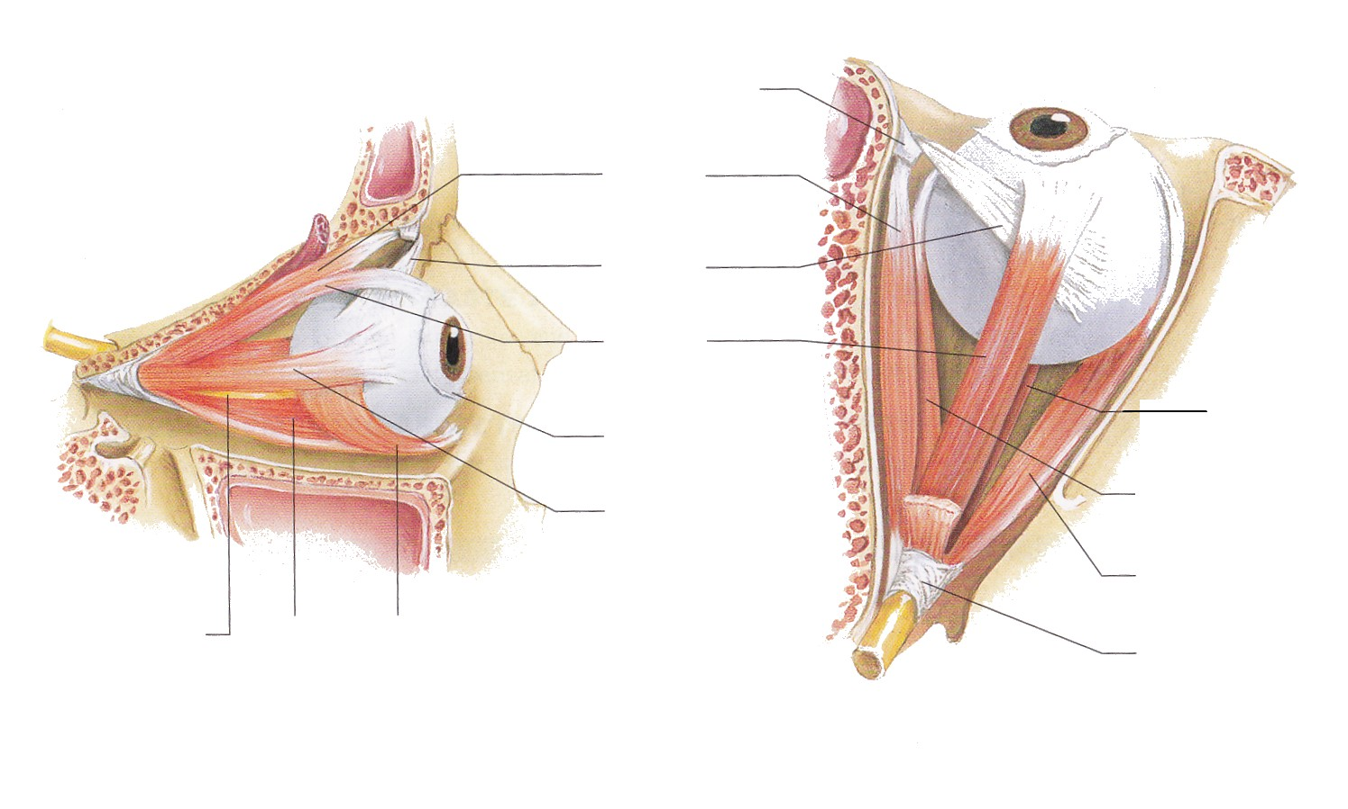
______ 1
______ 2
______ 3
______ 4
______ 5
______ 6
______ 7
______ 8
______ 9
______ 10
______ 11

Chapter 8: Special Senses Name_____________________________
Label the following Diagram. Place the correct letter in the space provided.
A. Iris B. Aqueous humor C. Cornea D. Fovea centralis
E. Scleral venous sinus F. Ciliary zonule G. Choroid H. Lens
I. Ciliary body J. Optic nerve K. Vitreous humor L. Pupil
M. Optic disc N. Retina O. Sclera
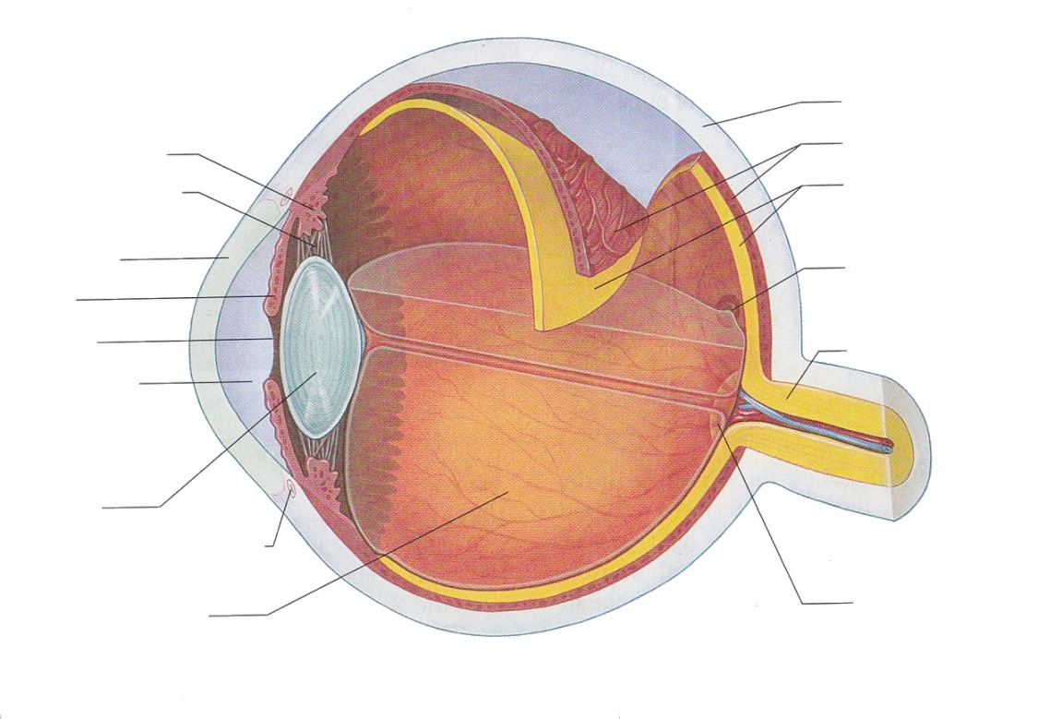
______1
______2
______3
______4
______5
______6
______7
______8
______9
______10
______11
______12
______13
______14
______15

