Chapter 8: Special Senses Name_____________________________

Label the following Diagram. Place the correct letter in the space provided.
A. Inner (interior) ear B. Middle ear C. Pharyngotympanic (auditory) tube D. Stirrup (stapes)
E. Oval window F. Outer (external) ear G. Vestibulocochlear nerve H. Anvil (incus)
I. Cochlea J. Tympanic membrane (eardrum) K. Ossicles L. Pinna (auricle)
M. Semicircular canals N. Round window O. Hammer (malleus) P. External acoustic meatus (auditory canal)
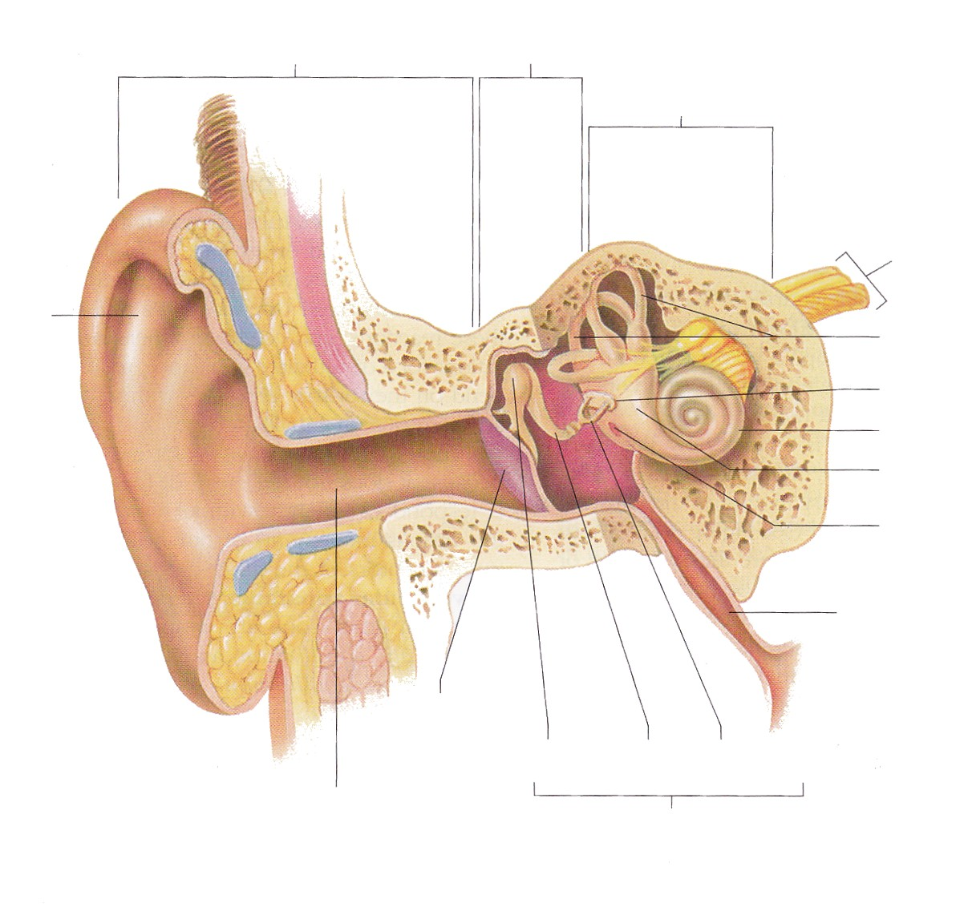
Q. Vestibule

______1
______2
______3
______4
______5
______6
______7
______8
______9
______10
______11
______12
______13
______14
______15
______16
______17

