Chapter 8: Special Senses Name___________________________
Label the Eye Diagram (Horizontal section)
Place the correct label into the blanks provided. Some information is already given.
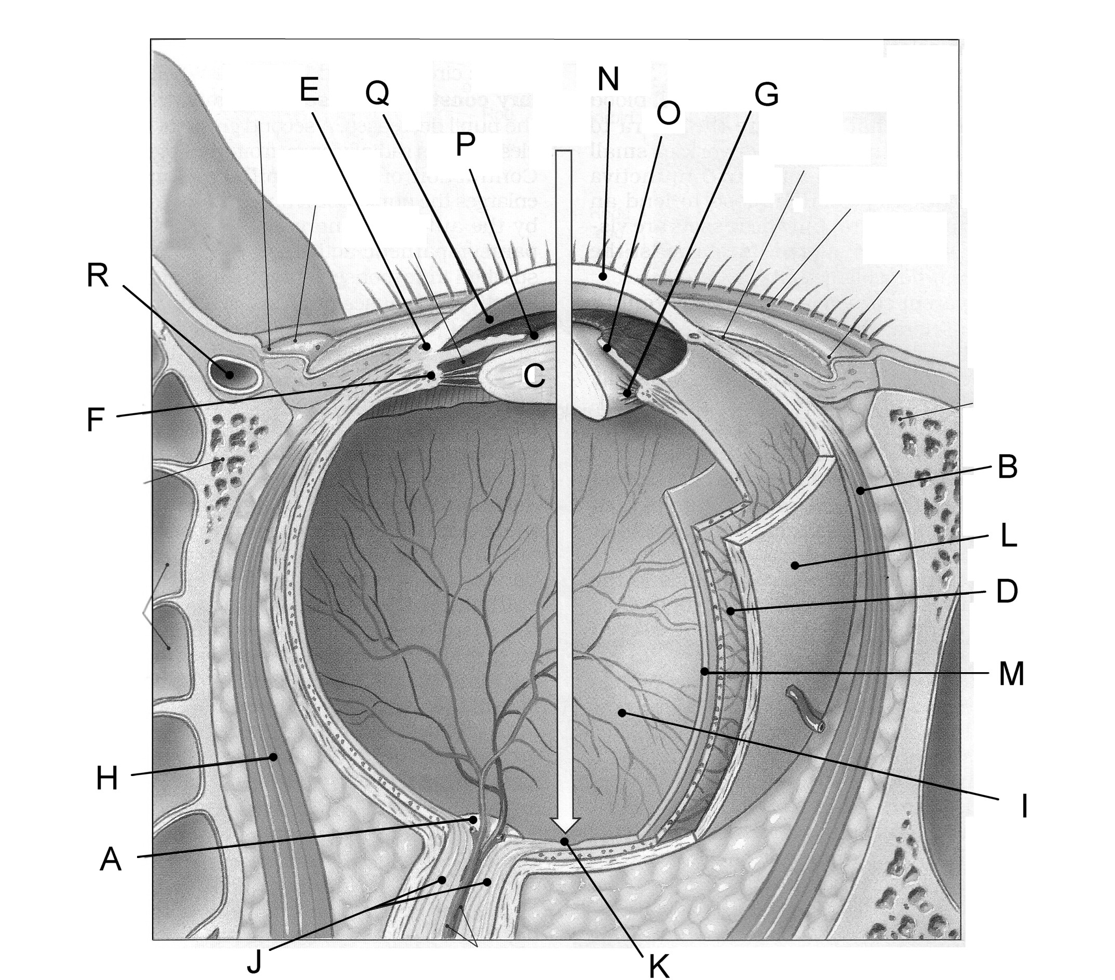

A ____________________________________ J ___________________________________
B ____________________________________ K ___________________________________
C ____________________________________ L ___________________________________
D ____________________________________ M ___________________________________
E ____________________________________ N __________________________________
F ____________________________________ O ___________________________________
G ____________________________________ P ___________________________________
H ____________________________________ Q ___________________________________
I _____________________________________ R ____________________________________

