A & P Chapter 11: Cardiovascular System Name___________________
Directions: For the top diagram of the heart, place the letter “d” into the circles in areas of the heart carrying deoxygenated blood. Place the letter “O” into the circles in areas of the heart carrying oxygenated blood. For the lower diagram, write the numbers 1-5, at the end of the label lines to indicate the correct order of the firing of each element of the intrinsic conduction system. Also, using both diagrams, place the correct labels at the bottom of the page.
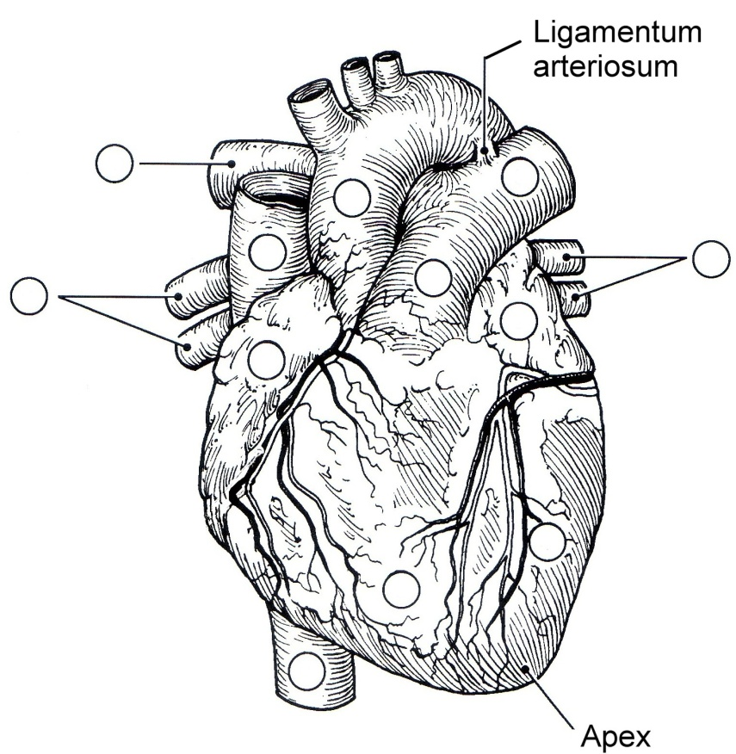

B

A

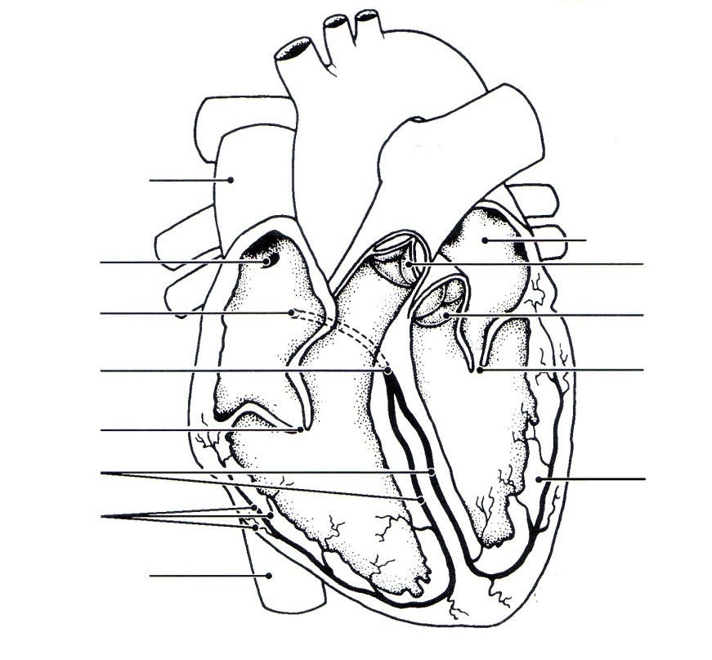
C

H

E
F

G
D

I

A__________________________ B__________________________ C__________________________

D__________________________ E__________________________ F__________________________

G__________________________ H__________________________ I__________________________

